**Assignment 5: Auto-Tagging EC2 Instances on Launch Using AWS Lambda and Boto3**

**1: Create IAM Role for Lambda**

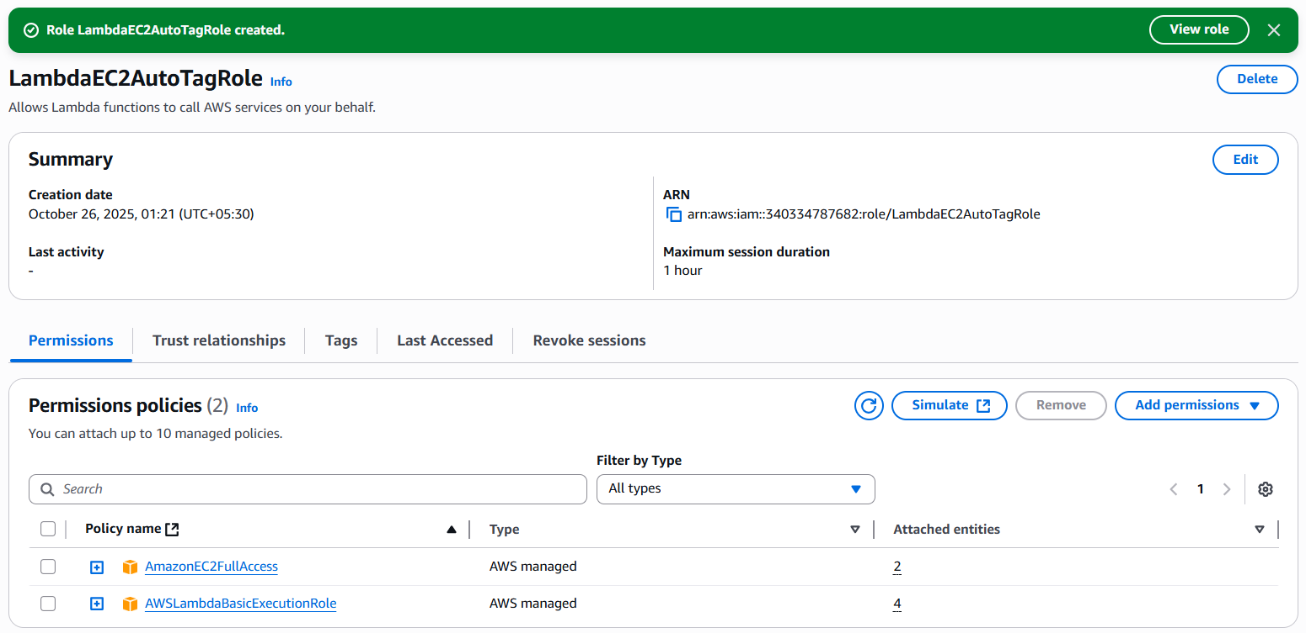

**2: Create the Lambda Function**

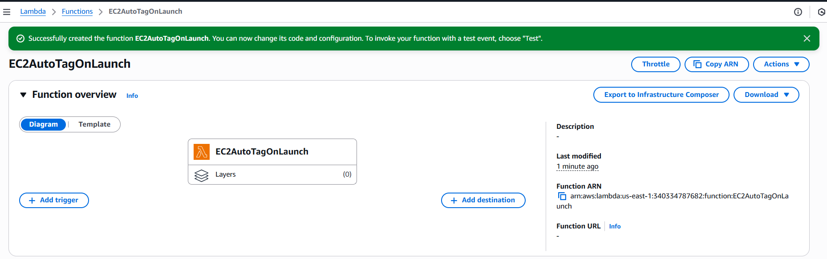

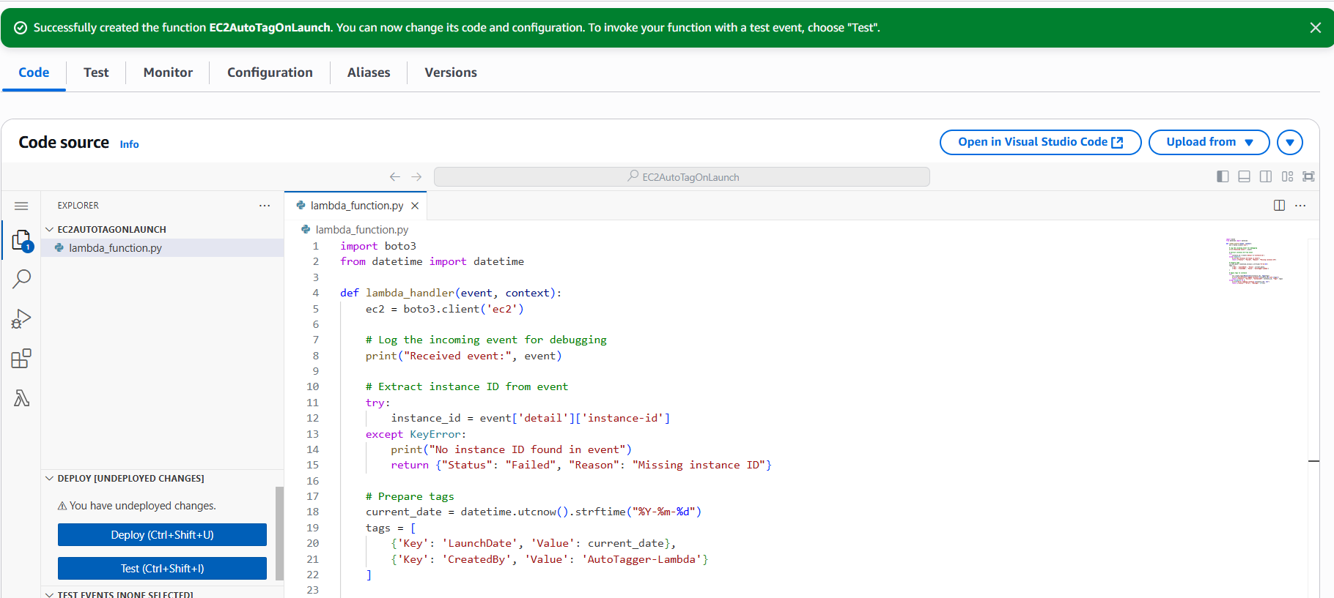

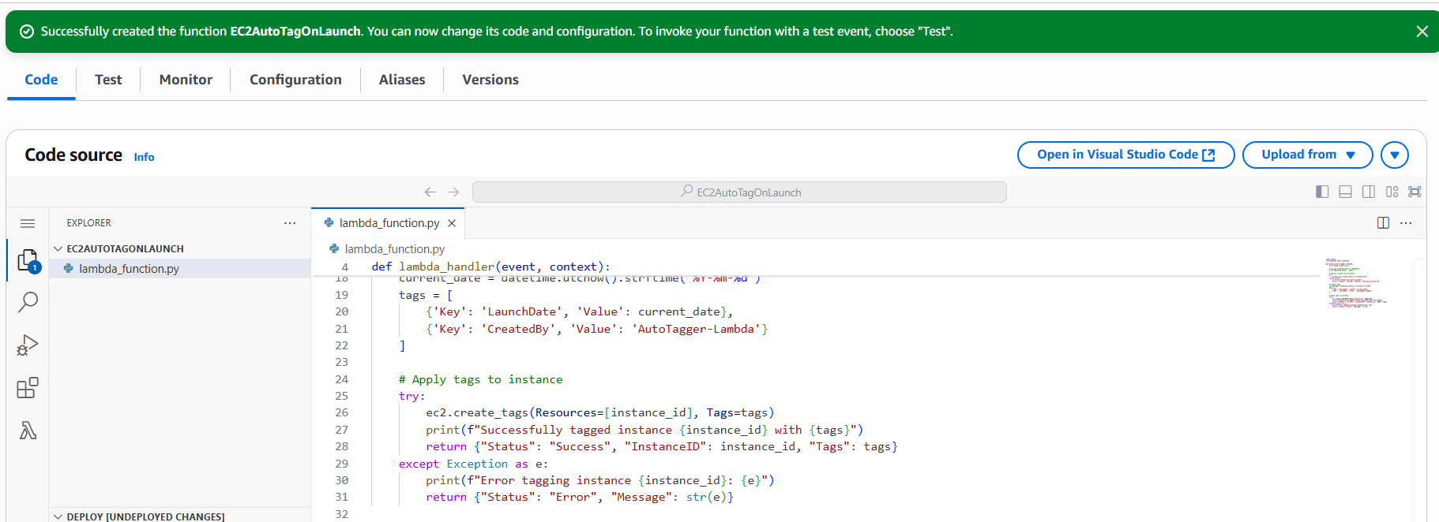

**3: Configure EventBridge (CloudWatch Events)**

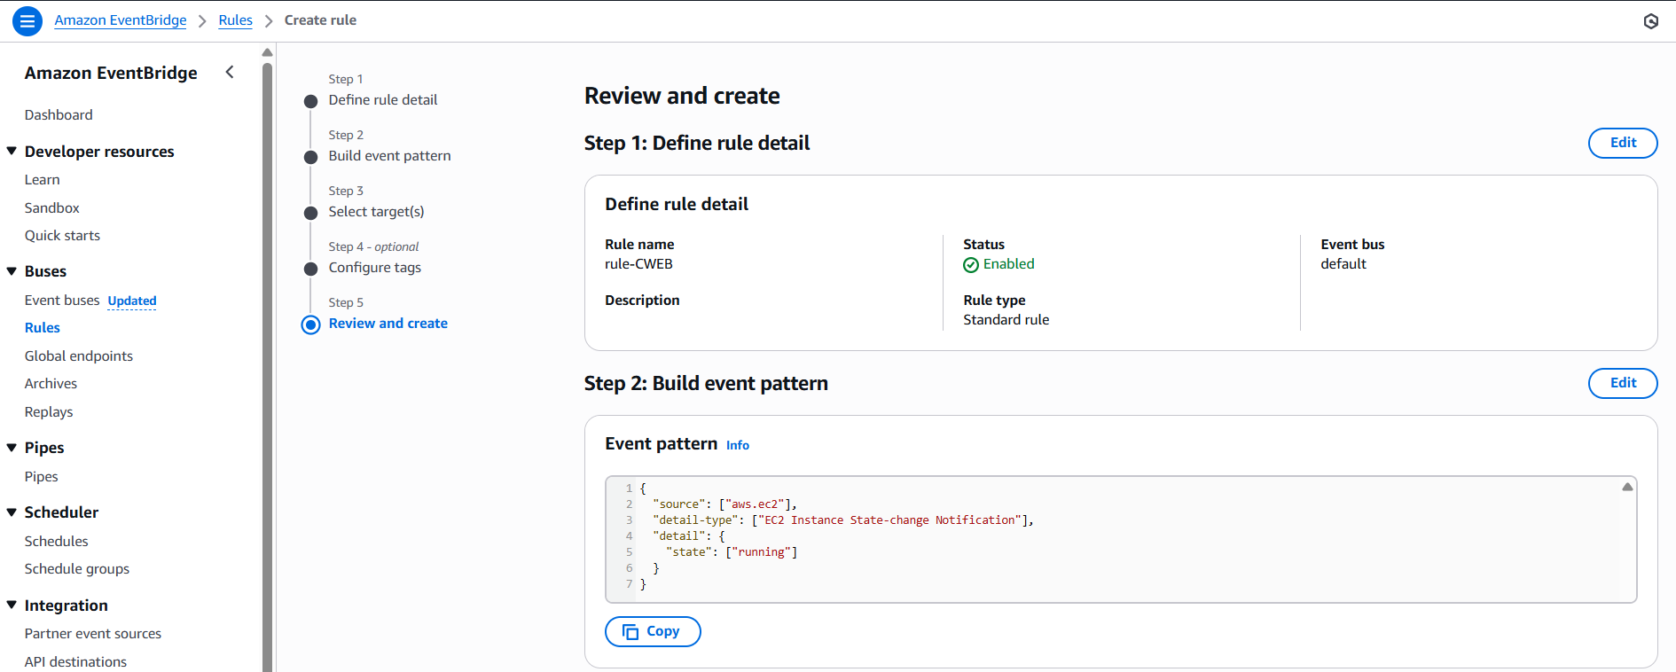

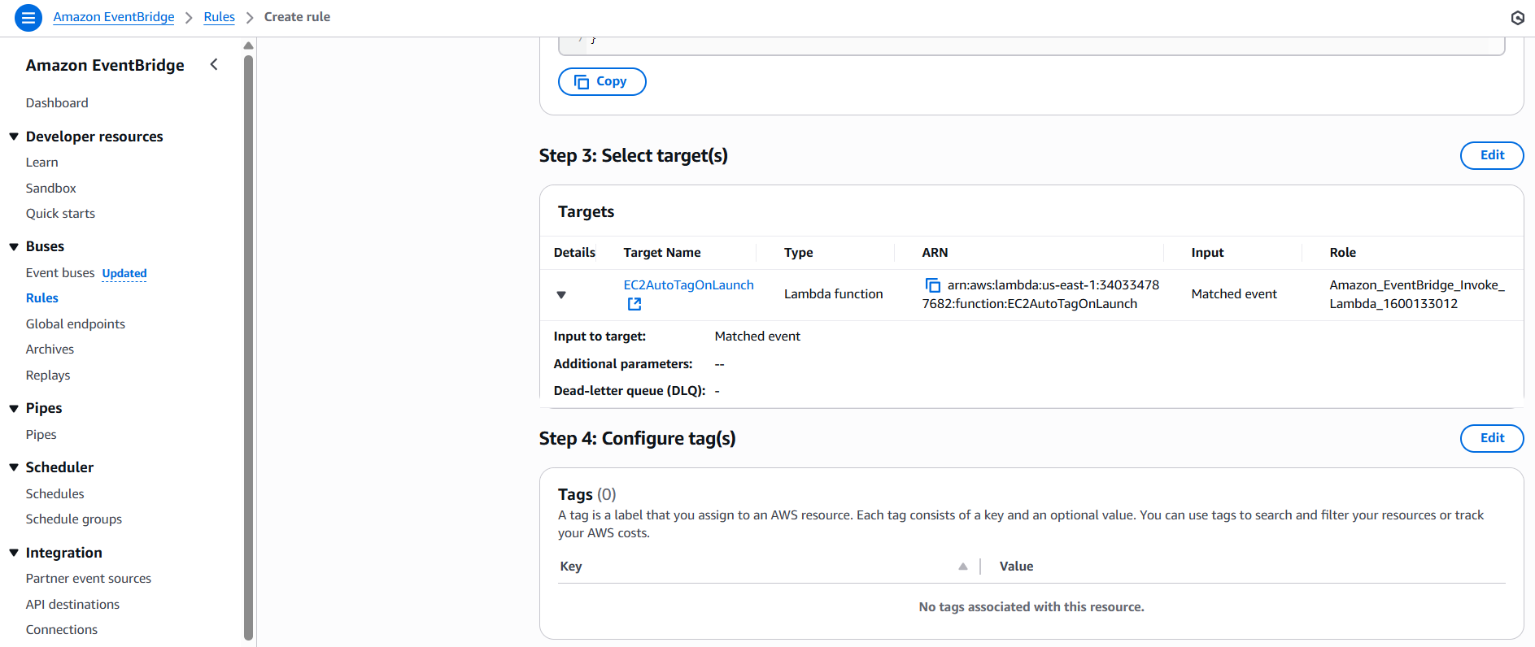

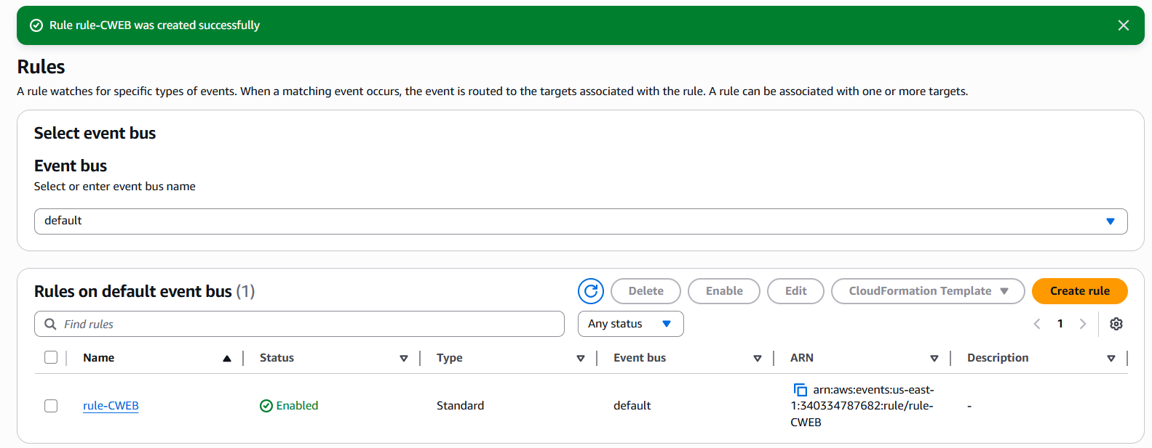

**4: Test the Setup**

